[1]

Authentication on Using IC Surfaces

Jiawei Gao

# INTRODUCTION

# Background And Preliminaries

## Diffuse Reflection Model for Norm Vector Estimation in Scanner’s Case

A fully diffuse light reflection model may be characterized as follows:

$$l_{r}=\frac{l}{{\left\|o-p\right\|}^{2}}\left\{w_{d}∙{\left(n^{T}v\right)}^{+}\right\}$$

In scanner’s case, the light source is linear and close to the chip surface, so the linear light source appears to a pixel on the paper infinitely long in its direction.

Under the fully diffuse model, the intensity of one point can be calculate by the integral over all rays generated by the linear light. Take linear light along *x* direction as an example:

$$I=\int_{-a}^{a}{l_{r}}do_{x}$$

Two images obtained when scanner acquires the chip in two opposite directions, $0°$ and $180°$, can be used to get the *y*-component of the norm map by their difference.

$$δI=l∙w_{d}\int_{-a}^{a}{n^{T}\frac{\left(o_{x},o_{y},o_{z}\right)-(o_{x},-o_{y},o_{z})}{{\left\|(o_{x},o_{y},o_{z})\right\|}^{3}}do_{x}=n_{y}∙s}$$

Similarly, the *x*-component of the norm map can be estimated by the difference of two images obtain in $90°$ and $270°$.

## Diffuse Reflection Model for Norm Vector Estimation in Camera’s Case

Unlike the scanner’s case, the light source in camera’s case is not a linear light and can be modeled as an infinitely long source. It is a point-source light, so we need to generate another derivation analyzing mathematically the inaccuracy due to the unparalleled rays by the point-source light from a finite distance for the camera’s case.

We base our derivation on fully diffuse model. There is indeed a specular component, but we only analyze the diffuse reflection component, and in the Section Ⅴ, we try to eliminate the specular reflection. Fig.1 shows the derivation.

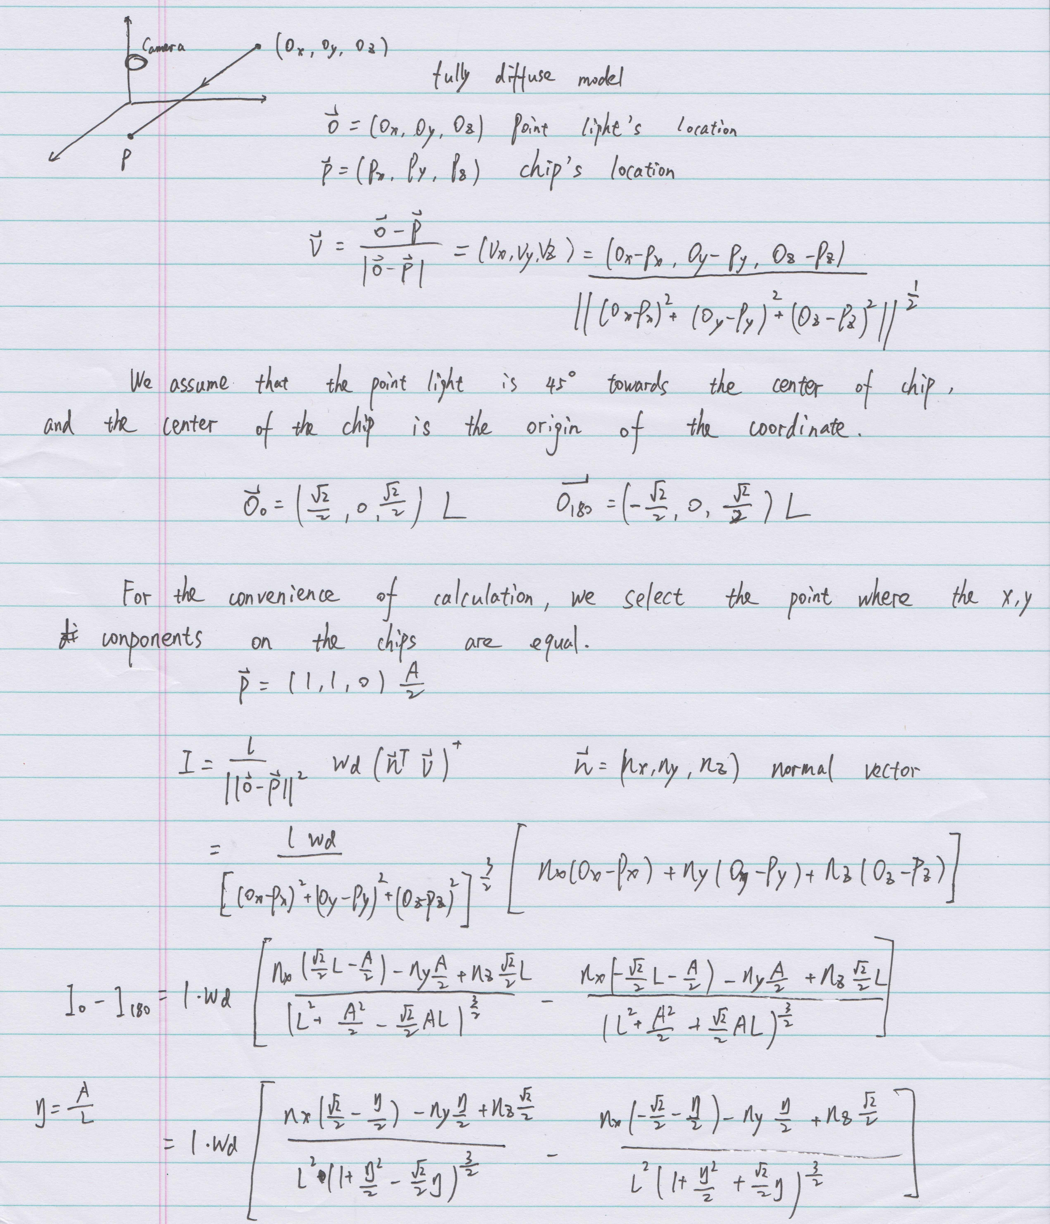

**Fig.1** : the derivation for the point light model

When *η* is closed to 0, the norm map can be estimated by the difference of two images captured by camera in opposite light directions.

$$I_{0}-I_{180}=\frac{l∙w_{d}∙n_{x}∙\sqrt{2}}{L^{2}}\left(when η→0\right)$$

We investigate how much the absolute error is when the light distance and point position is changing. We use the norm map calculated by the difference of camera-captured pictures ignoring the absolute error, uniform its magnitude with confocal data and calculate the *z*-component, thus we have produced the input data. We assume that each point in the input data is independent and co-distributed, so the sample average converges in probability towards the expected value. We can take the average of the absolute errors of each sample point as the overall mean, then use the mean and sample points to calculate the sample standard deviation.

Fig.2 shows the absolute error plot. In our case, 40 cm can produce negligible error, when the absolute error is around 0.2981. While $mean+std$ and $mean-std$ are very close to the curve $means$, which implies that the result is stable and won’t have large change due to different norm map data.

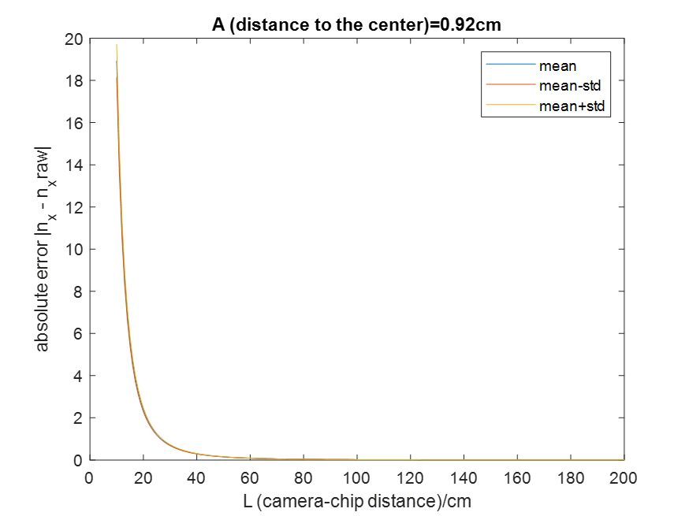

**Fig.2** :Absolute error

## Alignment for Images Only having Translation, Rotation and Scaling

We use a Matlab function *imregcorr*[1]to do the alignment for the pictures with translation, rotation and scaling. The algorithm is introduced as follows:

**Translation**

In spatial domain, the translation can be represented as follows:

$$f_{2}\left(x,y\right)=f_{1}(x-x_{0},y-y_{0})$$

In frequency domain,

$$F_{2}\left(ε,η\right)={e^{-j2π(εx_{0}+ηy_{0})}*F}_{1}(ε,η)$$

We can use phrase correlation to figure out the translation.

$$\frac{F_{1}\left(ε,η\right){F_{2}}^{*}\left(ε,η\right)}{\left|F_{1}\left(ε,η\right)F_{2}\left(ε,η\right)\right|}=e^{j2π\left(εx_{0}+ηy_{0}\right)}$$

**Rotation**

In spatial domain, the translation can be represented as follows:

$$f_{2}\left(x,y\right)=f_{1}\left(x\cos{θ_{0}+y\sin{θ_{0}}}-x_{0},-x\sin{θ_{0+}}y\cos{θ_{0}}-y_{0}\right)$$

In frequency domain,

$F_{2}\left(ε,η\right)={e^{-j2π\left(εx_{0}+ηy_{0}\right)}*F}_{1}(ε\cos{θ_{0}}+η\sin{θ_{0}},$ $-ε\sin{θ_{0}}+η\cos{θ_{0}})$

After converting the magnitude of it to polar representation, we can still figure out the rotate angle using phrase correlation.

$$M_{2}\left(ρ,θ\right)=M_{1}(ρ,θ-θ_{0})$$

**Scaling**

$$F_{2}\left(ε,η\right)=\frac{1}{\left|ab\right|}F_{1}(ε/a,η/b)$$

Converting the axes to **logarithmic(log) scale**, scaling can be reduced to a translational movement(ignoring the multiplication factor 1/(ab) ), i.e.

$$F_{2}\left(\log{ε},\log{η}\right)=F_{1}\left(\log{ε}-\log{a},\log{η}-\log{b}\right)$$

If $\left(x,y\right)$ is scaled to $\left(x/a,y/a\right)$, the polar representation will be

$$ρ_{1}={(x^{2}+y^{2})}^{1/2}, ρ_{2}=(1/a){(x^{2}+y^{2})}^{1/2}$$

$$θ_{1}=θ_{2}=\tan^{-1}{y/x}$$

If $f_{1}$ is translated, rotated, and scaled replica of $f_{2}$, their Fourier magnitude spectra in polar representation are related by

$$M_{1}\left(ρ/a,θ\right)=M_{2}(ρ/q,θ-θ_{0})$$

$$M_{1}\left(\log{ρ},θ\right)=M_{2}(\log{ρ}-\log{a},θ-θ_{0})$$

$$M_{1}\left(ε,θ\right)=M_{2}(ε-d,θ-θ_{0})$$

# IC Authentication Using SCANNERS And Cameras

## Scanner (Canon LIDE 110)

According to the fully diffuse model of scanner’s case, an estimate of one direction of norm map can be obtained by the subtraction between two scans in opposite directions. Thus, we scan groups of scans from 4 different direction: $0°, 90°, 180°,$ and $270°$.

For current work, a template need to be generated for the alignment of collected images. For different chips, the pattern and location of the text are different. So every chip need its own template. We choose some groups and use one align them with the image of a carefully cut chip, then calculate the average of them.



**Fig.3** : Templates for 4 chips

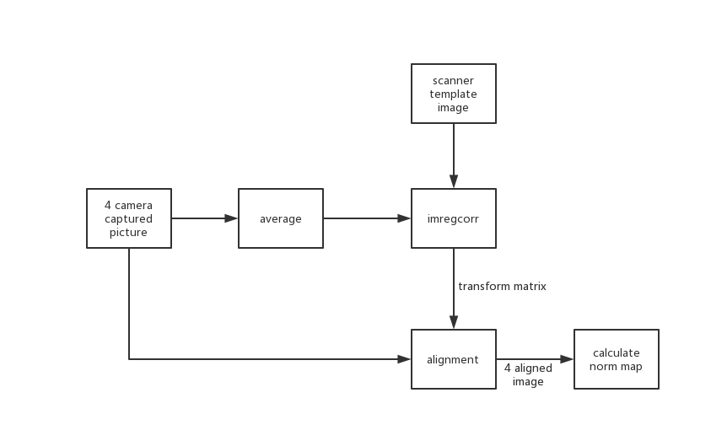

**Fig.4** : Flow chart for calculating norm map

Once the templates are generated, we can conduct the correlation analyses. For example, if we want to investigate, whether the input group is from chip1, template of chip1 will be used to align the input scans. Then we calculate the norm map of input and compare with the reference. Normal vector’s *x* and *y* components are used for correlation analyses. Fig.5 reveals that when input and reference are correctly matched, the correlation of norm map will be much bigger than those unmatched case, suggesting a good authentication performance. Table.1 and Table.2 show the specific correlation result.



**Fig.5** : Result of the correlation analyses in scanner’s case

**Table 1** : Correlation of norm map X in scanner’s case

|  |  |  |  |  |  |
| --- | --- | --- | --- | --- | --- |
| Norm map X | | Set4(Reference) | | | |
| Chip1 | Chip2 | Chip3 | Chip4 |
|
| Set5(input) | Chip1 | 0.6904 | -0.0029 | -0.0107 | 0.0004 |
| Chip2 | 0.0091 | 0.4407 | 0.0177 | 0.0004 |
| Chip3 | -0.0021 | 0.0068 | 0.3149 | -0.0073 |
| Chip4 | -0.0461 | -0.0064 | 0.0041 | 0.4299 |

**Table 2** : Correlation of norm map Y in scanner’s case

|  |  |  |  |  |  |
| --- | --- | --- | --- | --- | --- |
| Norm map Y | | Set4(Reference) | | | |
| Chip1 | Chip2 | Chip3 | Chip4 |
|
| Set5(input) | Chip1 | 0.6363 | 0.0686 | 0.0598 | 0.0699 |
| Chip2 | 0.1364 | 0.5359 | 0.0847 | -0.0700 |
| Chip3 | 0.0712 | 0.0970 | 0.7653 | 0.0579 |
| Chip4 | 0.0515 | 0.0666 | 0.0632 | 0.7485 |

## Camera (iPad 2018)

Photometric stereo is a technique in computer vision for estimating the surface normals of objects by observing that object under different lighting conditions. For the camera’s case, we fix the camera and the chip’s location and change the direction of the light’s direction, so there will be no alignment error when calculating the norm map. We use a 60 W bulb to make sure the light intensity is strong enough, keep a distance of 40 cm from the chip to reduce the error due to unparalleled rays and illuminate the chip at 45 degrees.

Fig.6 shows the result of correlation analyses in camera’s case. Unlike the scanner case, the correlation between matched and mismatched pairs is both high, while matched pairs are much higher, which can still distinguish the two scenarios. Table.3 and Table.4 show the specific correlation result.



**Fig.6** : Result of the correlation analyses in camera’s case

**Table 3** : Correlation of norm map X in camera’s case

|  |  |  |  |  |  |  |
| --- | --- | --- | --- | --- | --- | --- |
| Camera captured images | | | reference | | | |
| Set3 | | | |
| Chip1 | Chip2 | Chip3 | Chip4 |
| input | Set2 | Chip1 | 0.5917 | 0.2920 | 0.3073 | 0.2661 |
| Chip2 | 0.2750 | 0.6231 | 0.3269 | 0.2855 |
| Chip3 | 0.2882 | 0.2912 | 0.5951 | 0.2533 |
| Chip4 | 0.2226 | 0.2340 | 0.2666 | 0.5313 |

**Table 4** : Correlation of norm map Y in camera’s case

|  |  |  |  |  |  |  |
| --- | --- | --- | --- | --- | --- | --- |
| Camera captured images | | | reference | | | |
| Set3 | | | |
| Chip1 | Chip2 | Chip3 | Chip4 |
| input | Set2 | Chip1 | 0.4307 | 0.2417 | 0.2316 | 0.2090 |
| Chip2 | 0.2371 | 0.4522 | 0.2209 | 0.1941 |
| Chip3 | 0.2467 | 0.2283 | 0.4912 | 0.2213 |
| Chip4 | 0.2065 | 0.1866 | 0.1792 | 0.4960 |

# Sensitivity Analysis Due to Alignment Error and IC Surface’s Structure

The alignment mentioned in Section Ⅲ.B for the image is not perfectly accurate. We calculate the 2D autocorrelation of norm map to investigate how many pixels of alignment error can be allowed. Fig.7 shows the 1D curves extracted from the 2D autocorrealtion, suggesting that even 1 pixel translation can cause a big error in final result. The resolution is 600 dpi, which means one pixel is 42 μm.

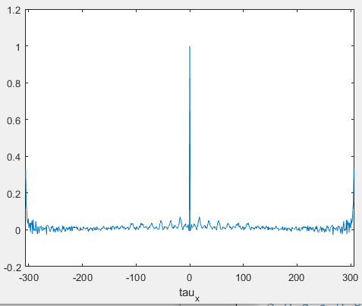 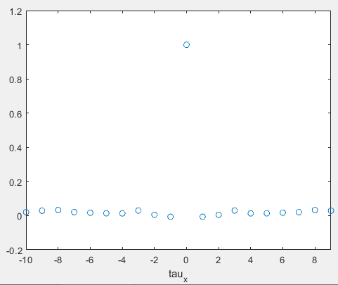 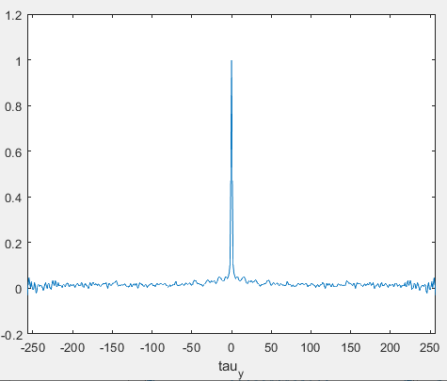 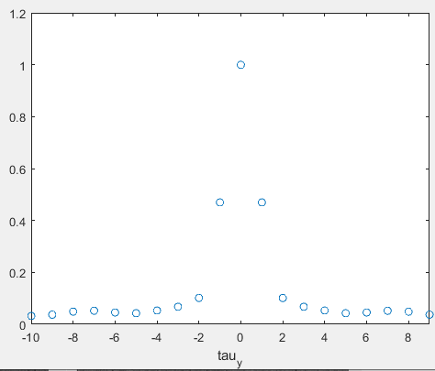

**Fig.7** : 1D curves that passing through the center from the 2D autocorrelation of norm map

In addition to the conclusion of how much error is allowed, we have another interesting discovery. It can be observed that, there is obvious periodicity in the *x* direction, suggesting the structure of the IC surface is periodically grooved along the *x* direction, probably because of the processing technology of the chip surface. The movement of the printed or polished knife in the *y* direction results in periodicity in the *x* direction.

Fig.8 contains 2D FFT plot of IC surface. In frequency domain, we can observe the continuous impulse along the x direction, which means that, in spatial domain, there will still be a continuous impulse along the x direction. It is the same result as the autocorrelation experiment above.

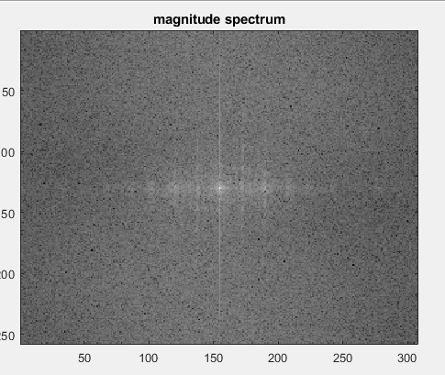

**Fig.8** : 2D FFT of IC surface’s image

Then we calculate the autocorrelation for the height map obtained from confocal microscope. What’s more, the length of approximately 10 pixels of the confocal microscope is equivalent to the length of one pixel of the scanner. Fig.9 shows that 5 or 6 pixels’ translation in alignment for confocal microscope data will cause the drop.



**Fig.9** : 1D curves that passing through the center from the 2D height map from confocal microscope.

# Scanner-Camera Verification On IC Surface

To do the scanner-camera verification, we need to make a preliminary processing of the images in the camera case. Since the brightness of the four images is different, we need to balance their brightness to calculate the norm map. Fig.10 shows the histogram of the image’s intensity and the Gaussian fitted curve. The abscissa of the curve symmetry point can reflect the brightness of the image. After getting the brightness of four images, we can balance them to the same intensity.



**Fig.10** : Histogram of the captured image’s intensity

After obtaining images of brightness balance, we make a scatter plot of x, y directions for each set of chips. For those points that are far from the diagonal, we guess they are the highlights caused by specular reflection and replace these points with the average of the points around these points. The points on the processed scatter plot (Fig.11) are significantly more concentrated near the diagonal. After marking these points on the original image, from Fig.12 , we can observe that most of these are bright spots on the original image.



**Fig.11** : Scatter plot



**Fig.12** : The point adjusted on the original image

After those preliminary steps, we calculate the norm map for the camera case, reconstruct the height maps for both scanner and camera, and get the subbands. Correlation analyses are carried out between norm map and height map’s subbands.

## Norm map

The authentication is feasible but not so obviously good. The matched cases have higher correlations in the x and y directions than the unmatched cases, except for some cases, which may be caused by the wrong position of the light source.

Fig.13 shows the correlation analysis in norm map. Table.5 and Table.6 show the specific correlation results.



**Fig.13** : Correlation of the norm map between scanner and camera

**Table.5** : Correlation of norm map X between scanner and camera cases

|  |  |  |  |  |  |  |
| --- | --- | --- | --- | --- | --- | --- |
| Norm map X | | | scanner | | | |
| Chip1 | Chip2 | Chip3 | Chip4 |
| input | Set2 | Chip1 | **0.2238** | -0.0370 | -0.0942 | -0.0406 |
| Chip2 | 0.0172 | **0.0718** | -0.0525 | -0.0534 |
| Chip3 | -0.0418 | -0.0240 | **0.0775** | -0.0617 |
| Chip4 | -0.0092 | -0.0264 | -0.0710 | **0.2169** |

**Table.6** : Correlation of norm map Y between scanner and camera cases

|  |  |  |  |  |  |  |
| --- | --- | --- | --- | --- | --- | --- |
| Norm map Y | | | scanner | | | |
| Chip1 | Chip2 | Chip3 | Chip4 |
| input | Set1 | Chip1 | **0.0702** | -0.0685 | -0.0568 | -0.0317 |
| Chip2 | -0.0579 | **0.1091** | -0.0596 | -0.0100 |
| Chip3 | -0.0703 | -0.0706 | **0.0956** | -0.0598 |
| Chip4 | -0.0086 | -0.0507 | -0.0787 | **0.0700** |

## Subbands of reconstructed height map

We reconstruct the height map for both scanner and camera cases using the norm map and confocal data, then extract 10 subbands of the height map.

In the high frequency subbands, the matching cases’ correlations are higher than the unmatched cases’. Although they are not particularly high, they are still distinguishable. Fig.14 shows result of the correlation analysis for 10 subbands.

       



**Fig.14** : Correlation of the reconstructed height map’s subbands between scanner and camera

# References

[1] Reddy, B. S. and Chatterji, B. N., An FFT-Based Technique for Translation, Rotation, and Scale-Invariant Image Registration, IEEE Transactions on Image Processing, Vol. 5, No. 8, August 1996

1.